**PUBLIC NOTICE**

Notice is hereby given that the East Zion Special Service District’s Administrative Control Board is looking to fill one vacant position. The term for this position will expire 12/31/2021. Each subsequent term will be 4 years in length.

Applicants wishing to apply for this position must own property, and be a registered voter, within the district.

Applicants will be interviewed by the commissioner assigned as a liaison to this district, who will then make a recommendation for appointment to the full County Commission at the July 27, 2021 Kane County Commission meeting.

Anyone interested in filling this position may submit a signed letter of interest and a brief resume to the Kane County Commission, c/o Kresta Blomquist, Kane County Courthouse, 76 North Main, Kanab, Utah 84741, by **5:00 pm, July 23, 2021**. Hand delivered letters may be dropped off in the Clerk’s Office at the Kane County Courthouse. Email submissions can be sent to: [klblomquist@kane.utah.gov](mailto:klblomquist@kane.utah.gov).

For questions pertaining to these positions call Kresta Blomquist (435) 644-4330.

Dated June 23, 2021,

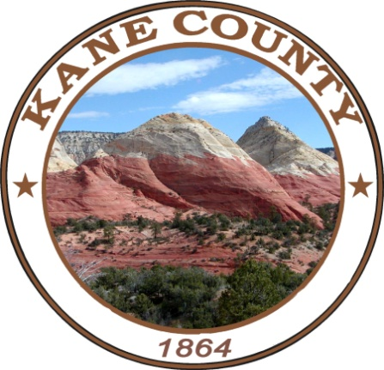

___________________________________________

Kresta Blomquist, Administrative Assistant, Kane County Commission

Published: *Southern Utah News*

Publication date: July 16, 2021

Kane County Commission

76 North Main Street

Kanab, Utah 84741